Equity Application

## Instructions

Instructions for “Equity Application”

**Please read and follow all the instructions for a proper use of this application!**

## Pre-requisites:

1. **TB template** – should be made based on the template provided down below:



In the TB Template, map the information from the Trial Balance provided by the client, onto the header shown here accordingly. (Account, Description, Opening Balance (OB), Debit Movement (DM), Credit Movement (CM) and Closing Balance (CB))

|  |  |  |  |  |  |
| --- | --- | --- | --- | --- | --- |
| Account | Description | OB | DM | CM | CB |
| 401 | Vendors | 2.341 | 34.325 | 5.353 | 31.313 |

**\*Note:** In the template, columns Synt(2), Synt(3) & Synt(4) are automatically filled in by the app based on Account inputs.

## Instructions:

1. After connecting to the platform, go to **Equity**:

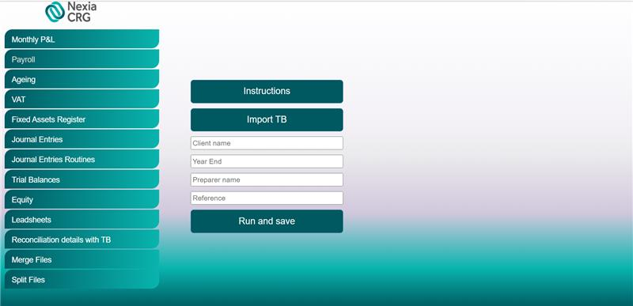

1. Click “Import TB” button and select the TB template.
2. In the “Client name”, “Year End” (Date of the audit), “Preparer name” and “Reference” introduce the information accordingly.
3. Click “Run and save”. Once clicking that, the robot will process your request and download the excel in your designated Downloads folder.
4. Finally, you should obtain an Excel document named “Equity” + “client name”

**Note: Please do not modify any of the templates provided!

If you encounter any issues or if you have any other questions or suggestions, please contact:

Cristian Iordache, [cristian.iordache@ro.gt.com](mailto:cristian.iordache@ro.gt.com)

Bogdan Constantinescu, bogdanconstantinescu@ro.gt.com